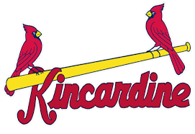
2026 Kincardine Minor Baseball Association Tournament Form

Team Name/Association: Click or tap here to enter text.
OBA Roster Number: Click or tap here to enter text.
Tournament: ☐ 13U May 29-31 ☐ 18U June 5-7 ☐14 AAA June 19-21
☐ 11U July 25-27 ☐ 15U July 25-27
Coach Name: Click or tap here to enter text.
Coach Email: Click or tap here to enter text.
Coach Phone: Click or tap here to enter text.

Manager/Alternate Contact Name: Click or tap here to enter text.
Manager/Alternate Contact Email: Click or tap here to enter text.
Manager/Alternate Contact Phone: Click or tap here to enter text.

Cost for each tournament is $650. Payment can be transferred to the KMBA treasurer kmbabaseballreg@gmail.com . Registration will be considered official once this form is submitted payment is received. For teams requiring overnight accommodation, please ensure that appropriate arrangements are made before registering, refunds will not be issued due to lack of hotel rooms.
Each team will be guaranteed a minimum of 3 games, with the first being played on the Friday evening. Finals will be played on the Sunday.
All tournaments are intended for OBA teams expected to be classified as “A” and below for the 2026 season. Teams allowed to enter will be at the sole discretion of the host association in the interest of competitive balance and availability of overnight accommodation.

Please direct any questions to:
Jeremy McQuillin, KMBA Tournament Coordinator
quillyon@hotmail.com
519-955-1487

